**Chapter 1**

**Introduction**

* 1. **Problem Statement & Objective**

**Problem:** Improper system for feedback regarding airport facilities.

**Reasons:** The reason for building the web app is to get the feedback regarding the airport facilities which are provided at the airport and to manage the database from which passengers can access for their belongings.

**Solution:** This app would help the management and co-ordination between the passengers and airport staff. The purpose of the Inventory management system for taking feedback at the airport is to create a convenient and easy-to-use application for passengers. The system is based on a relational database. Above all, we hope to provide a comfortable user experience with this managerial application.

This system can be used to accomplish following tasks, keeping in mind that this software will have an adequate life:

* SATS gives the facility to provide co-ordination between airport staff and passengers.
* Also allows the passengers to access their belongings.

This is an advance step towards an automated system that can be useful to passengers to provide feedback and to access their belongings.

**Objective:** The purpose of this document is to build an online system to take feedback regarding airport facilities which are provided at the airport. The project is based on an web app using which the airport authority can manage the database and passengers can access for their belonging.

* 1. **Investigation & Analysis**

All users of this module can do the following functions using SATS application.

**Passengers**

* Can submit their feedback according their preference.
* They can provide their experience based feedback after using airport provided services.
* Can see their flight details

**Administrative**

* Check the feedbacks provided by the passengers

**System Analysis**

System analysis is the process of gathering and interpreting facts, diagnosing problems and using the information to recommend improvements on the system. System analysis is a problem solving activity that requires intensive communication between the system users and system developers. System analysis or study is an important phase of any system development process. The system is studied to the minutest detail and analyzed. The system analyst plays the role of an interrogator and dwells deep into the working of the present system. The system is viewed as a whole and the inputs to the system are identified. The outputs from the organization are traced through the various processing that the inputs phase through in the organization.

A detailed study of these processes must be made by various techniques like Interviews, Questionnaires etc. The data collected by these sources must be scrutinized to arrive to a conclusion. The conclusion is an understanding of how the system functions. The designer now functions as a problem solver and tries to sort out the difficulties that the enterprise faces. The solutions are given as a proposal. The proposal is presented to the user for an endorsement by the user. The proposal is reviewed on user request and suitable changes are made. This loop ends as soon as the user is satisfied with the proposal.

Analysis gathers the requirements for the system. This stage includes a detailed study of the business needs of the organization.

Design focuses on high level design like, what programs are needed and how are they going to interact, low-level design (how the individual programs are going to work), interface design (what are the interfaces going to look like) and data design (what data will be required).

During these phases, the software's overall structure is defined. Analysis and Design are very crucial in the whole development cycle. Any glitch in the design phase could be very expensive to solve in the later stage of the software development. The logical system of the product is developed in this phase.

* 1. **Introduction to Project**

The purpose of this document is to build an online system to take feedback regarding airport facilities which are provided at the airport. The project is based on an web app using which the airport authority can manage the database and passengers can access for their belonging.

This project is a prototype for the Inventory management system for taking feedback at the airport and it is restricted within the college premises. This has been implemented under the guidance of college professors. This project is useful for the airport authority and as well as to the passengers.

The purpose of the Inventory management system for taking feedback at the airport is to create a convenient and easy-to-use application for passengers. The system is based on a relational database. Above all, we hope to provide a comfortable user experience.

This project is a prototype for the Inventory management system for taking feedback at the airport and it is restricted within the college premises. This has been implemented under the guidance of college professors. This project is useful for the airport authority and as well as to the passengers.

* 1. **Proposed Solutions**

**Proposed System**

1. The proposed system is intranet based system so passengers can also participate in viewing their belongings.
2. The proposed provides detail general information about the passengers along with their personal/basic information and their arrival and destination places.
3. It enhances the HR management in adding, viewing and updating passenger's details and generates various reports regarding passenger's belongings.

At a conceptual level, there may be many different kinds of objects within a given site that are accessible to users. At the physical level, these objects may be represented by one or more Web pages. Conceptually, each of these entities represents a different type of semantic object. During a visit to this site, a user may access several of these objects together during a session. In contrast to content features, ontological representation of domain knowledge contained in the site makes it possible to have a uniform architecture to model such objects. In this section we will present a general framework for fully utilizing domain ontologies in Web usage mining and personalization. Figure 1 lays out a general process for such an integrated approach. As before, it is composed of 3 main phases: preprocessing, pattern discovery and online recommendation. Each of these phases must now take into account the object properties and their relationships.

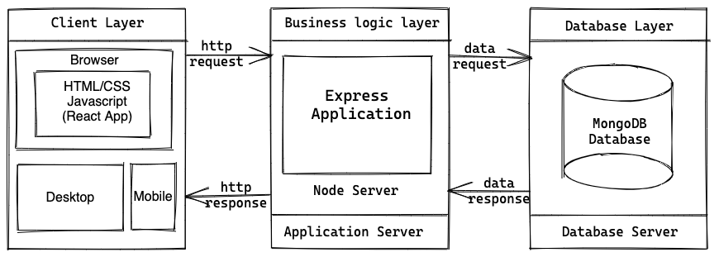

**Figure 1.1: Architecture Diagram of the Proposed System Methodology**

* 1. **Scope of the Project**

The purpose of the Inventory management system for taking feedback at the airport is to create a convenient and easy-to-use application for passengers. The system is based on a relational database. Above all, we hope to provide a comfortable user experience.

**Chapter 2**

**System Requirements Specifications**

* 1. **Overall Description**

This section and its subsections contain the description of the project components such as interfaces, performance requirements, design constraints, assumptions and dependencies etc.

* + 1. **Product Perspective**

The application will be a web application.

* + - 1. **System Interfaces**

List each system interface and identify the functionality of the system (hardware and software both) to accomplish the system requirement and interface description to match the system.

* + - 1. **User Interfaces**

The application will have a user friendly and menu based interface. Following screens will be provided:

* An inventory management database system stores the following information.
* **User details:** The database consists of the username, password, contact, gender, email id. These details provide valid login to user after getting registered.
* **Admin details:** The DB consists of the username, password, contact, gender, email id, address. These details provide valid login to an admin of a particular airport after getting registered.
  + - 1. **Hardware Interfaces**
* Screen resolution of at least 800 x 600 pixels is required for proper and complete viewing of screens. Higher resolutions in wide-screen mode will be better for a better view.
* Support for printer is required. This implies that appropriate drivers should be installed and printer device should be connected for printing of reports and mark sheets.
* A network connection (internet / intranet) is required to make the web service accessible on other systems connected over the network.
* Other hardware interface specifications are as follows

**Minimum Requirements:**

|  |  |  |  |
| --- | --- | --- | --- |
| **Client Side** | | | |
|  | **Processor** | **RAM** | **Disk Space** |
| Google Chrome | Intel Pentium III or AMD -800 MHz | 128 MB | 100 MB |

**Table 2.1 Minimum Client Side Hardware Interface**

|  |  |  |  |
| --- | --- | --- | --- |
| **Server Side** | | | |
|  | **Processor** | **RAM** | **Disk Space** |
| Node.js | Intel Pentium III or AMD -800 MHz | 1 GB | 3.5 GB |
| MongoDB | Intel Pentium III or AMD -800 MHz | 256 MB | 500 MB  (Excluding Data  Size) |

**Table 2.2 Minimum Server Side Hardware Interface**

**Recommended Requirements:**

|  |  |  |  |
| --- | --- | --- | --- |
| **Client Side** | | | |
|  | **Processor** | **RAM** | **Disk Space** |
| Google Chrome | All Intel or AMD - 1 GHZ | 256 MB | 100 MB |

**Table 2.3 Recommended Client Side Hardware Interface**

|  |  |  |  |
| --- | --- | --- | --- |
| **Server Side** | | | |
|  | **Processor** | **RAM** | **Disk Space** |
| Node.js | All Intel or AMD - 2 GHZ | 2 GB | 3.5 GB |
| MongoDB | All Intel or AMD - 2 GHZ | 512 MB | 500 MB  (Excluding Data  Size) |

**Table 2.4 Recommended Server Side Hardware Interface**

* + - 1. **Software Interfaces**
* Any Microsoft Windows 7 and higher (Windows 7 / 8 / 8.1 / 10) or equivalent Linux based operating system with minimum kernel support 3.X.
* Crystal Reports 8 for generation and viewing of reports
* We have chosen web application for its best support and user-friendliness.
* To implement the project we have chosen VS Code for its more interactive support.

**Minimum Requirements:**

|  |  |  |
| --- | --- | --- |
| **Software Tool** | **Version** | **Purpose of Use** |
| Operating System | Windows 7 and higher or Linux with kernel 3.x and higher | Installation and operational platform |
| Web Browser | Google Chrome, Brave and other higher compatible | Access to the web application |
| Web Server | Node Server | Running the web application over intranet |
| Database | MongoDB | Running and linking the database over internet/intranet to the online web application |

**Table 2.5 Minimum Software Interface**

**Recommended Requirements:**

|  |  |  |
| --- | --- | --- |
| **Software Tool** | **Version** | **Purpose of Use** |
| Operating System | Windows 8 and higher or Linux with kernel 3.x and higher | Installation and operational platform |
| Web Browser | Google Chrome, Brave and other higher compatible | Access to the web application |
| Web Server | Node Server | Running the web application over intranet |
| Database | MongoDB | Running and linking the database over internet/intranet to the online web application |

**Table 2.6 Recommended Software Interface**

* + - 1. **Communication Interfaces**
* Passenger on Internet will be using HTTP/HTTPS protocol.
* Client (Administrator) on Internet will be using HTTP/HTTPS protocol.
  + - 1. **Memory Constraints**
* At least 256 MB of RAM and 2 GB of space on hard disk will be required for running the application on client end.
* Similarly, a minimum of 2048 MB of RAM and 20 GB of space on hard disk will be required for running the application on server end.
  + - 1. **Operations**
* The DBA at the client side will be assumed responsible for manually deleting or archiving obsolete or non-required data from the database as per clients requirements.
* This will include database backup and recovery options also.
* The Node webserver will be hosted and maintained on a remote server addressed by a URL based address.
* The URL address may be intranet or internet based as per clients requirements.
* The 'SYSTEM RESET' function is provided that after confirmation from the administrator, will delete all the selective or complete data from the system.
  + - 1. **Project Functions**

The system will allow access only to authorized users with specific roles (Passengers, Administrator etc.). Depending upon the user's role, he / she will be able to access only specific modules of the system.

A summary of the major functions that the software will perform:

1. A Login facility for enabling only authorized access to the system.
2. Passenger can view their flight details and can give feedbacks.
3. Admin can view feedbacks summary and feedback messages.
   * + 1. **User Characteristics**

* Educational Level: User should be at least graduate and comfortable with English.
* Experience: User should be well versed / informed about the structure of the program.
* Technical Expertise: User should be comfortable using general purpose applications on a computer.
  + - 1. **Constraints**
* Since the DBMS being used in this project is MongoDB, and the web server is Node Server, that are free open source tools, the server technologies are out of any guarantees, unless specifically purchased for enterprise environment.
* Due to limited features of DBMS being used, performance tuning features will not be applied to the queries and thus the system may become slow with the increase of data records being stored.
* Due to limited features of DBMS, database auditing will also not be provided.
* As the application runs over a network environment, well documented security policy is required to prevent and safeguard data as well as services over the network.
  + - 1. **Assumption & Dependencies**
* The number of domains being selected by the user does not change.
* The project Code will not change.
* The number of modules assigned to employee cannot be changed.

**Chapter 3**

**System Design Specifications**

* 1. **System Architecture**

System architecture presents the schematic view of the complete system along with its major components and their connectivity. The overall architecture of the proposed system will be as follows.

* 1. **Module Decomposition**

The proposed system can be decomposed into following major modules:

1. Login
2. Passenger
3. Admin
4. Database

**Module - 1:**

**Login Page:**

This is a common page for both the users, can either be passenger or admin.

It has this basic layout where the passenger needs to enter their name, email, number and PNR. For admin they have to enter their email and password.

There are dynamic pages linked to user of every profile.

**Module - 2:**

**Passenger:**

This is the other user page, i.e. the passenger page after login.

This is the passenger dashboard, passenger can use it to navigate to different section of the website and they can also view their flight details like airline name, aircraft name, flight departure date & time, flight arrival date & time, etc. on this page.

**Feedback Page:**

This page shows 8 different departments of the airport for which a passenger can give their feedback.

The 8 different departments are:

* Food Court
* Baggage
* Check In
* Help Desk
* Airlines
* Lounges
* Stores
* Washroom

**Feedback Form Page:**

After selecting the department in feedback page the passenger in redirect to the respective feedback form of that department and the passenger here can give their feedbacks based on different services or parameters between 0.5 and 5. They can also give the feedback message for the respective department.

**Module - 3:**

**Admin Page:**

This page is the first page after login a manager will see.

**Feedback Page:**

This page is the same as the one in passenger module. It also has the same 8 departments but when the admin clicks on it, he will be able to view the results to feedbacks given by the passengers.

**View Feedback Page:**

This page displays the feedbacks summary of the respective department in the form of circular progress bar. This page also displays the entire feedback message given by the passengers

**Module - 4:**

**Database:**

The overall objective in the development of database technology has been to treat data as an organizational resource and as an integrated whole. DBMS allow data to be protected and organized separately from other resources.

Database is an integrated collection of data. The most significant form of data as seen by the programmers is data as stored on the direct access storage devices. This is the difference between logical and physical data.

Database files are the key source of information into the system. It is the process of designing database files, which are the key source of information to the system. The files should be properly designed and planned for collection, accumulation, editing and retrieving the required information.

The organization of data in database aims to achieve three major objectives:

* Data integration.
* Data integrity.
* Data independence.

The proposed system stores the information relevant for processing in the MySQL SERVER database. This database contains tables, where each table corresponds to one particular type of information. Each piece of information in table is called a field or column.

A table also contains records, which is a set of fields. All records in a table have the same set of fields with different information. There are primary key fields that uniquely identify a record in a table.

* 1. **High Level Design Diagrams**
     1. **Use – Case Diagrams**

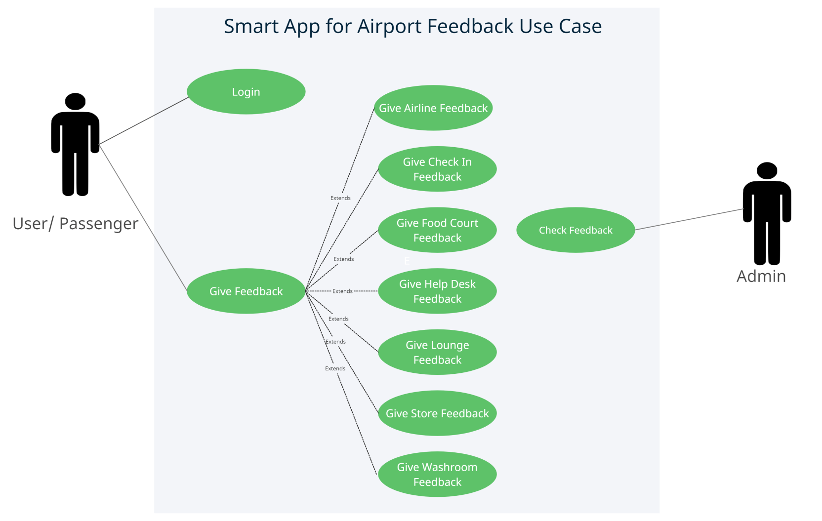

**Fig 3.1: Use - Case Diagram**

* + 1. **Activity Diagram**

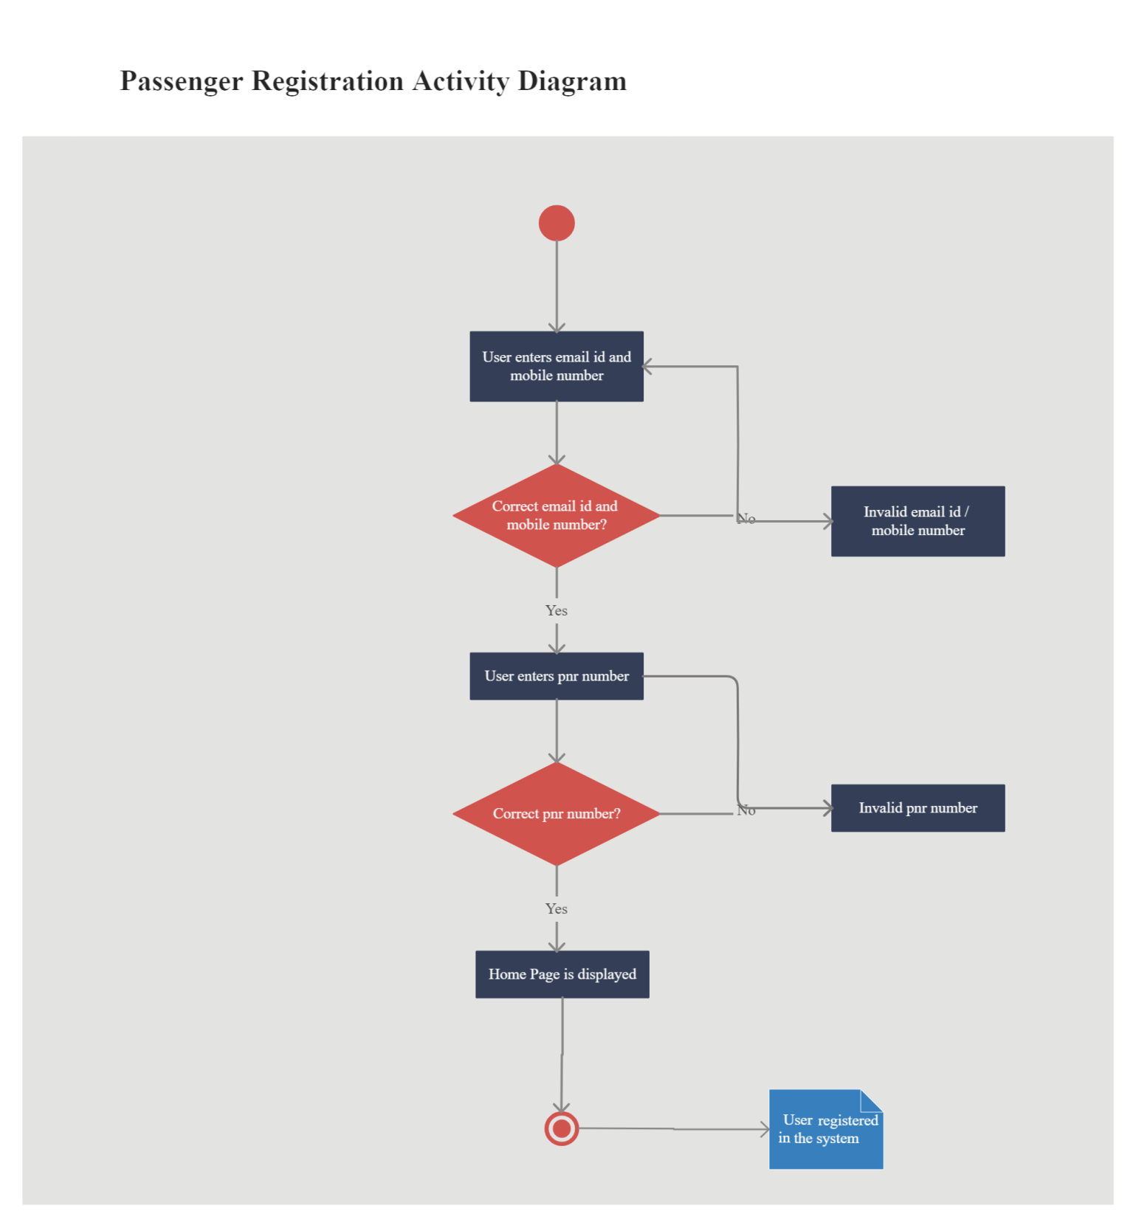

**Fig 3.2: Activity Diagram Representing Passenger Registration**

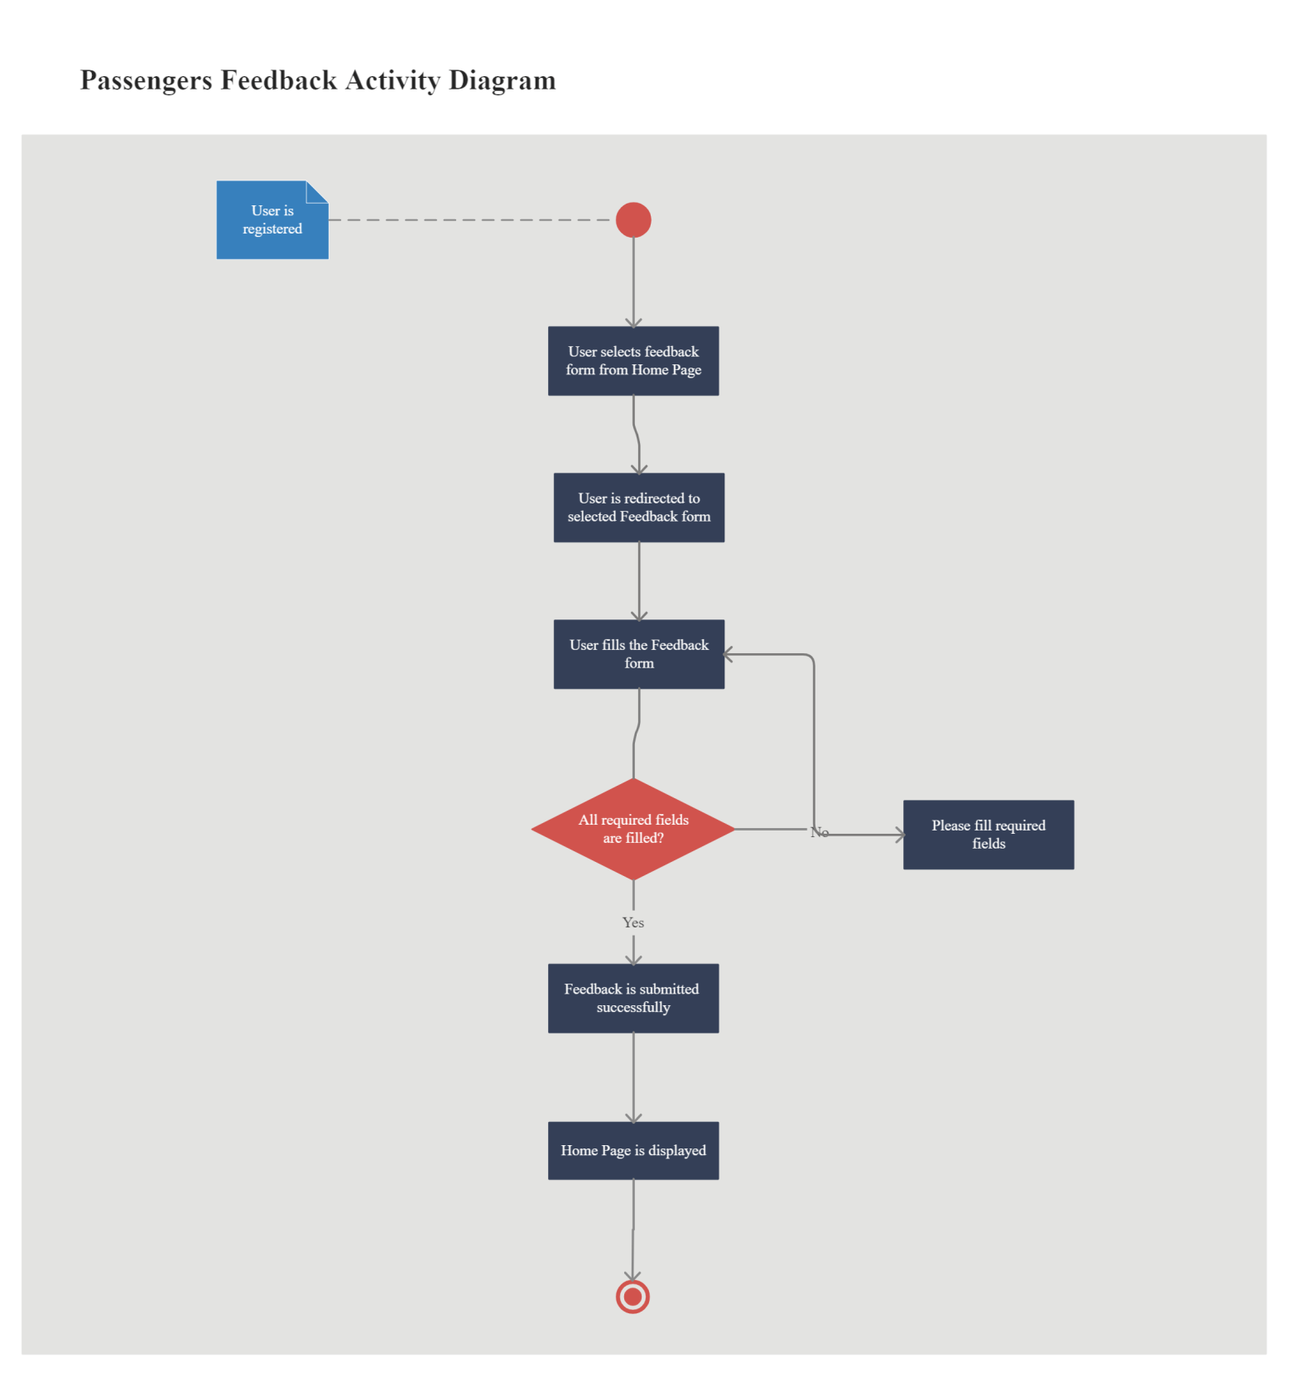

**Fig 3.3: Activity Diagram Representing Passenger Feedback**

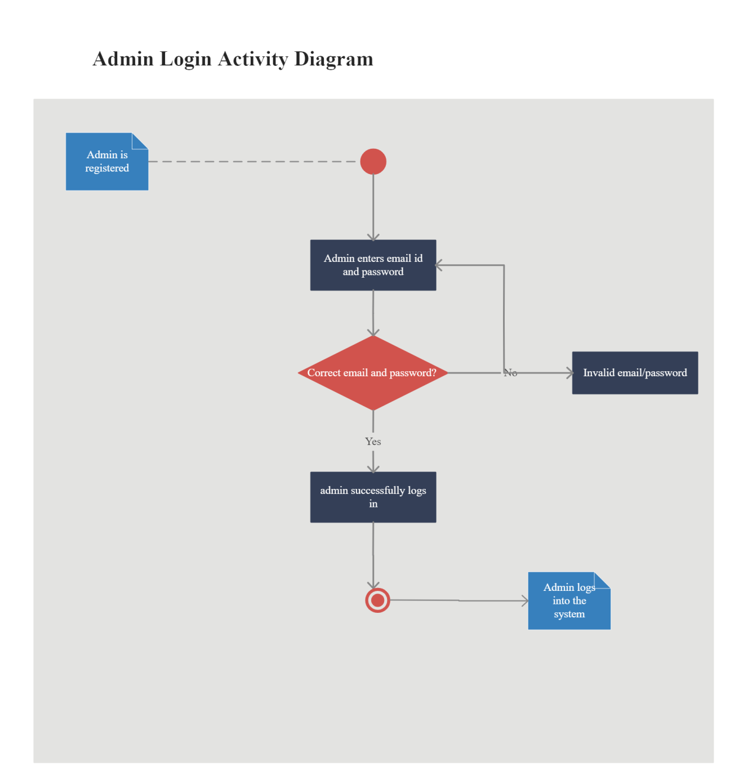

**Fig 3.4: Activity Diagram Representing Admin Login**

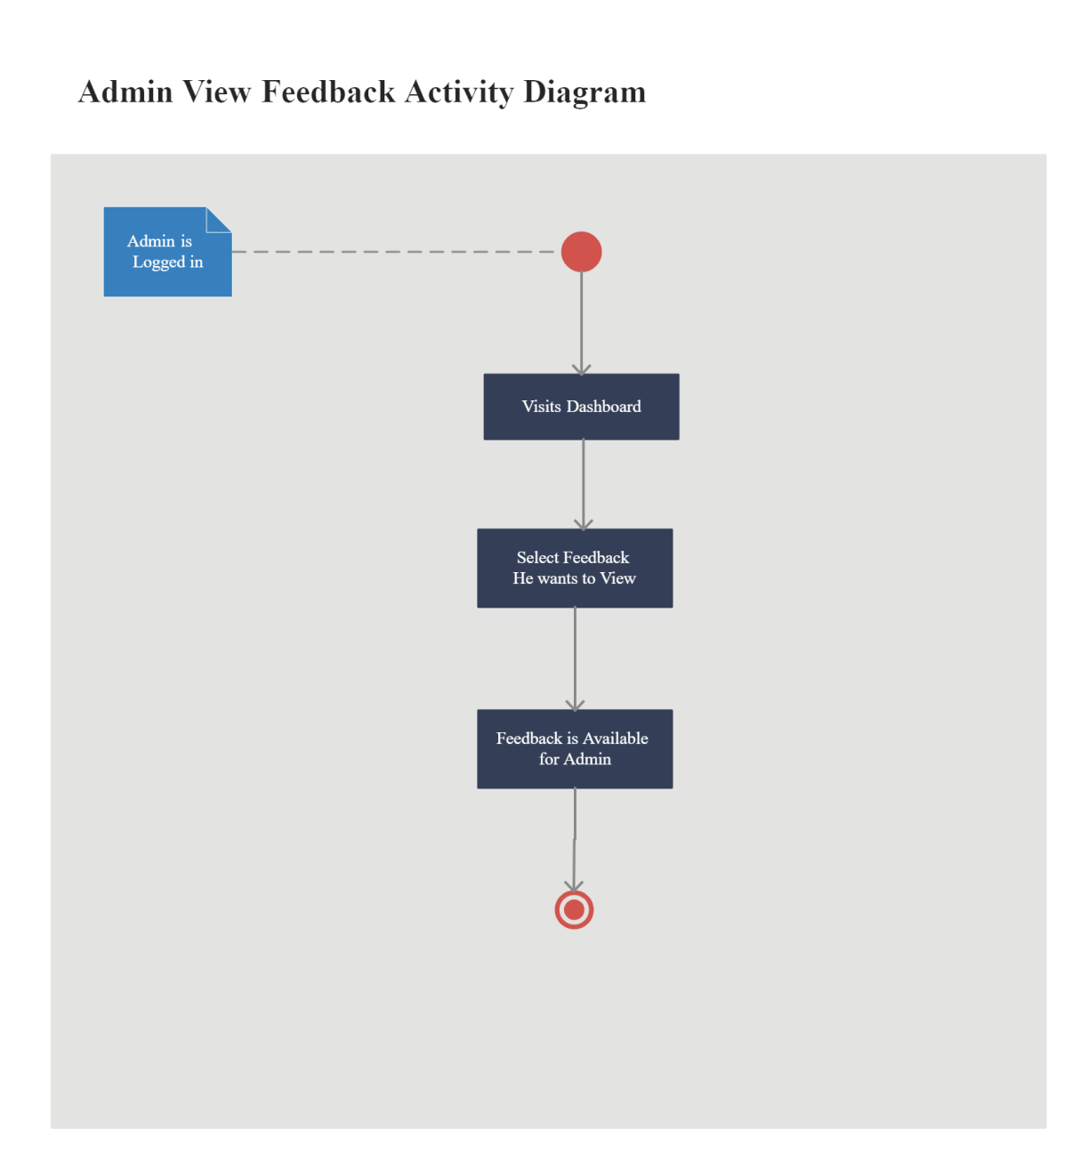

**Fig 3.5: Activity Diagram Representing Admin View Feedback**

* + 1. **Data Flow Diagram**

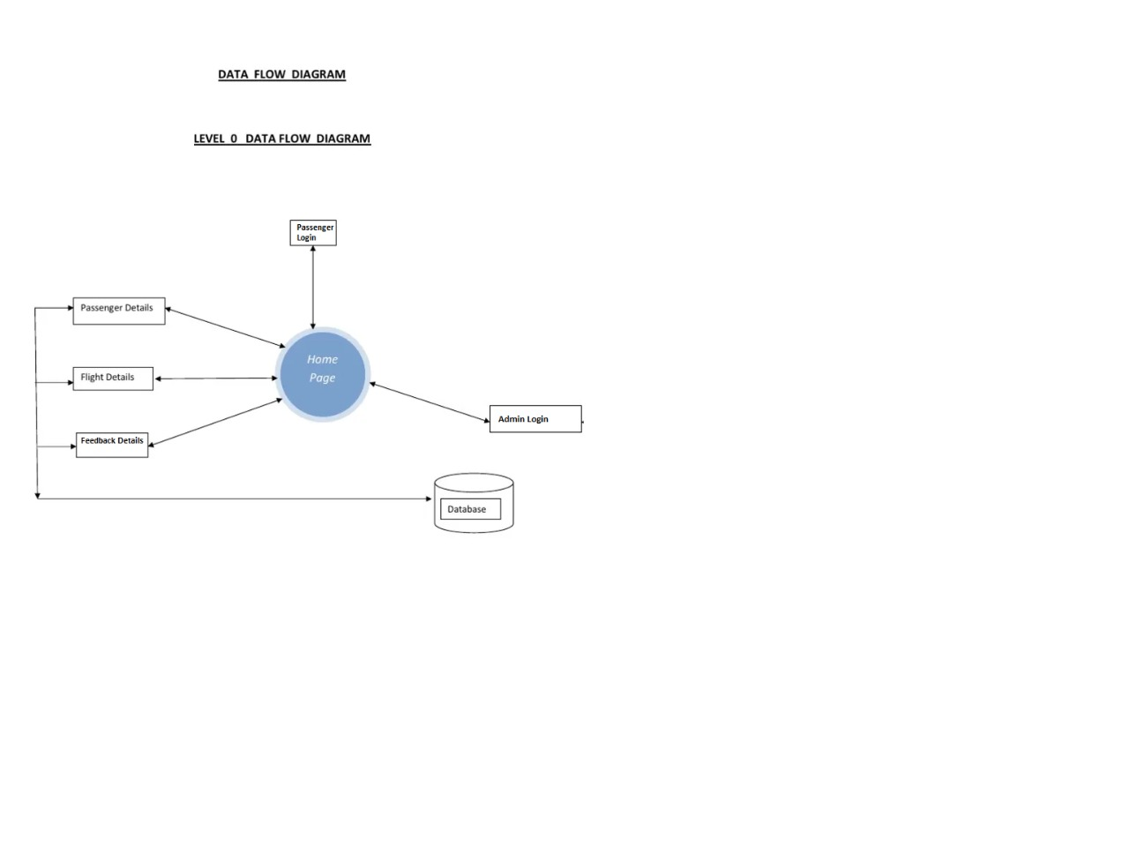

**Fig 3.6: Data Flow Diagram**

* + 1. **Class Diagram**

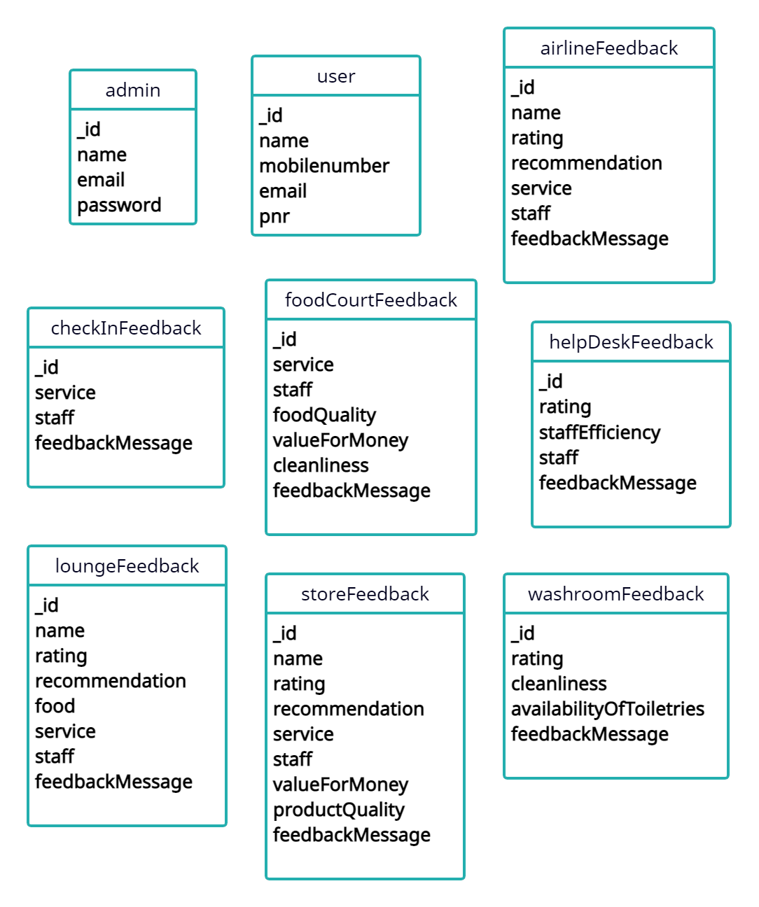

**Fig 3.8: Class Diagram**

**Chapter 4**

**Methodology and Team**

* 1. **Introduction to Waterfall Model**

The Waterfall Model was first Process Model to be introduced. It is also referred to as a linear-sequential life cycle model. It is very simple to understand and use. In a waterfall model, each phase must be completed before the next phase can begin and there is no overlapping in the phases.

The waterfall Model illustrates the software development process in a linear sequential flow; hence it is also referred to as a linear-sequential life cycle model. This means that any phase in the development process begins only if the previous phase is complete. In Waterfall model, typically, the outcome of one phase acts as the input for the next phase sequentially.

Following is a diagrammatic representation of different phases of waterfall model.

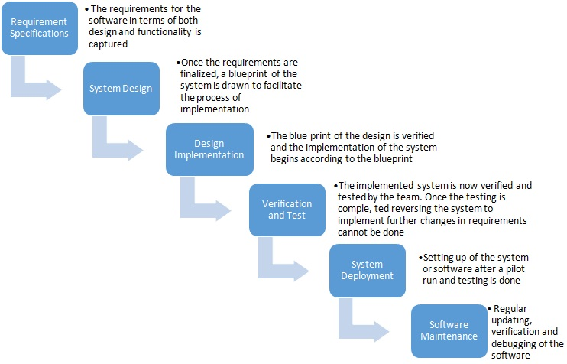

**Fig 4.1: Waterfall Model with Feedback**

The sequential phases in Waterfall model are:

* **Requirement Gathering and analysis:** All possible requirements of the system to be developed are captured in this phase and documented in a requirement specification doc.
* **System Design:** The requirement specifications from first phase are studied in this phase and system design is prepared. System Design helps in specifying hardware and system requirements and also helps in defining overall system architecture.
* **Implementation:** With inputs from system design, the system is first developed in small programs called units, which are integrated in the next phase. Each unit is developed and tested for its functionality which is referred to as Unit Testing.
* **Integration and Testing:** All the units developed in the implementation phase are integrated into a system after testing of each unit. Post integration the entire system is tested for any faults and failures.
* **Deployment of system:** Once the functional and non-functional testing is done, the product is deployed in the customer environment or released into the market.
* **Maintenance:** There are some issues which come up in the client environment. To fix those issues patches are released. Also to enhance the product some better versions are released. Maintenance is done to deliver these changes in the customer environment.

All these phases are cascaded to each other in which progress is seen as flowing steadily downwards through the phases. The next phase is started only after the defined set of goals are achieved for previous phase and it is signed off, so the name "Waterfall Model". Every software developed is different and requires a suitable SDLC approach to be followed based on the internal and external factors.

Some situations where the use of Waterfall model is most appropriate are:

* Requirements are very well documented, clear and fixed.
* Product definition is stable.
* Technology is understood and is not dynamic.
* There are no ambiguous requirements.
* Ample resources with required expertise are available to support the product.

**Waterfall Model Pros & Cons**

The advantage of waterfall development is that it allows for departmentalization and control. A schedule can be set with deadlines for each stage of development and a product can proceed through the development process model phases one by one.

The disadvantage of waterfall development is that it does not allow for much reflection or revision. Once an application is in the testing stage, it is very difficult to go back and change something that was not well-documented or thought upon in the concept stage.

* 1. **Team Members, Roles & Responsibilities**

|  |  |  |
| --- | --- | --- |
| **Team Members** | **Project Role** | **Responsibilities** |
| **Akshat Gadodia** | Team Member | Designing Database, Admin Module, Integration of all Modules, Authentication |
| **Akshita Sharma** | Project Manager | Frontend, Passenger Module, Styling |

**Table 4.1: Roles and Responsibilities**

**Chapter 5**

**Centering Testing System**

The designed system has been testing through following test parameters.

* 1. **Functionality Testing**

In testing the functionality of the web sites the following features were tested:

* **Links**

1. Internal Links:

All internal links of the website were checked by clicking each link individually and providing the appropriate input to reach the other links within.

1. External Links:

Till now no external links are provided in our website but for future enhancement we will provide the links to the candidate's actual profile available online and link up with the elections updates online etc.

1. Mail Links:

No mail links are provided in our website till this stage but this is also a future enhancement of our website to trigger mails to people for keeping them updated about the online registration dates, the polling dates and other details.

1. Broken Links:

Broken link are those links which so not divert the page to specified page or any page at all. By testing the links on our website there was no link found on clicking which we did not find any page.

* **Forms**

1. Field validation

Checks on dates have been applied. For e.g. The Date of birth should be less than the current date and after that we have checked the age to be greater than or equal to 18 years (the eligible age for casting vote). Checks have been applied on starting and ending dates, i.e. the starting dates of elections or registrations should always fall before their respective ending dates.

1. Error message for wrong input

Error messages have been displayed as and when we enter the wrong details (e.g. Dates), and when we do not enter any detail in the mandatory fields. For example: when we enter wrong password we get error message for acknowledging us that we have entered it wrong and when we do not enter the username and/or password we get the messages displaying the respective errors.

1. Optional and Mandatory fields

All the mandatory fields have been marked with a red asterisk (*) and apart from that there is a display of error messages when we do not enter the mandatory fields. For example: As the first name is a compulsory field in all our forms so when we do not enter that in our form and submit the form we get an error message asking for us to enter details in that particular field.

* **Database**

Testing is done on the database connectivity.

In the database testing we included following cases:

1. Entries in database through frontend and checked for the same in the tables.
2. Checked for the data types.
3. Checked for range of each type of data.
4. If entries made in one table are affecting other tables then we have checked those entries also.
5. We not just added details in the database by default but also did the same using the frontend.

**5.2 Performance Testing**

Performance testing can be applied to understand the website's scalability, or to benchmark the performance in the environment of third party products such as servers and middleware for potential purchase. This can only be done once it is put into use on the actual internet server and tested by the users.

Till now it is done using the null modem on two systems.

The system load includes:

1. What is the number of users per time?
2. Checking for peak loads and how system behaves.
3. Amount of data accessed by user.

This is done using only 2 systems for now so cannot be tested for load unless we deploy it on a real server machine.

* 1. **Usability Testing**

Usability testing is the process by which the human-computer interaction characteristics of a system are measured, and weaknesses are identified for correction.

1. Ease of learning
2. Navigation
3. Subjective user satisfaction
4. General appearance

As system is not put into the real time use so it's not yet tested for usability.

**Chapter 6**

**Test Execution Summary**

Execution Test Summary Report is an overall view of Testing Process from start to end. Test Plan comes at the starting of project while Test Summary Report comes at the end of testing process. This report is given to the client for his understanding purpose.

The Test Summary Report contents are:

1. Test Case ID generated = PRO1, PR02
2. Total number of resources consumed = 2
3. Passed Test Cases = 2
4. Failed Test cases = O
5. Status of Test Cases = Passed

**Table 6.1: Test Case Summary**

**Chapter 7**

**Project Screen Shots**

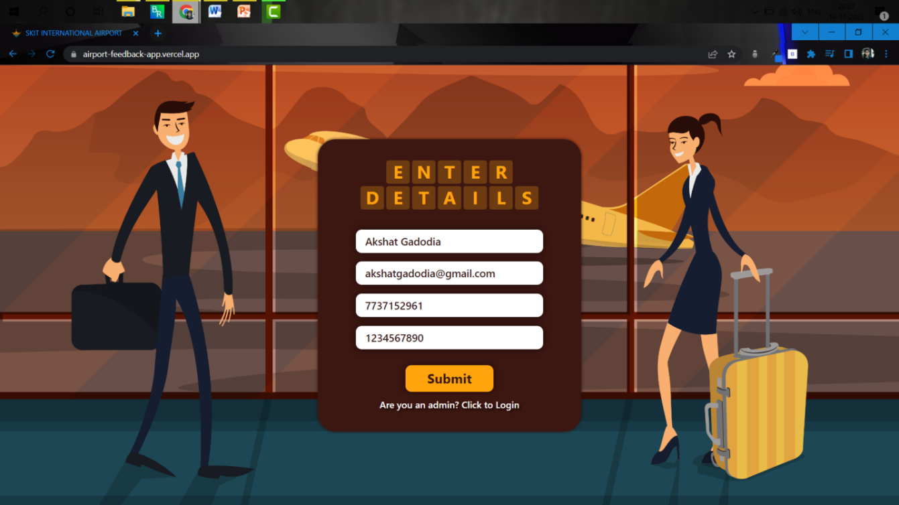

**Fig 7.1: Passenger Login Screen**

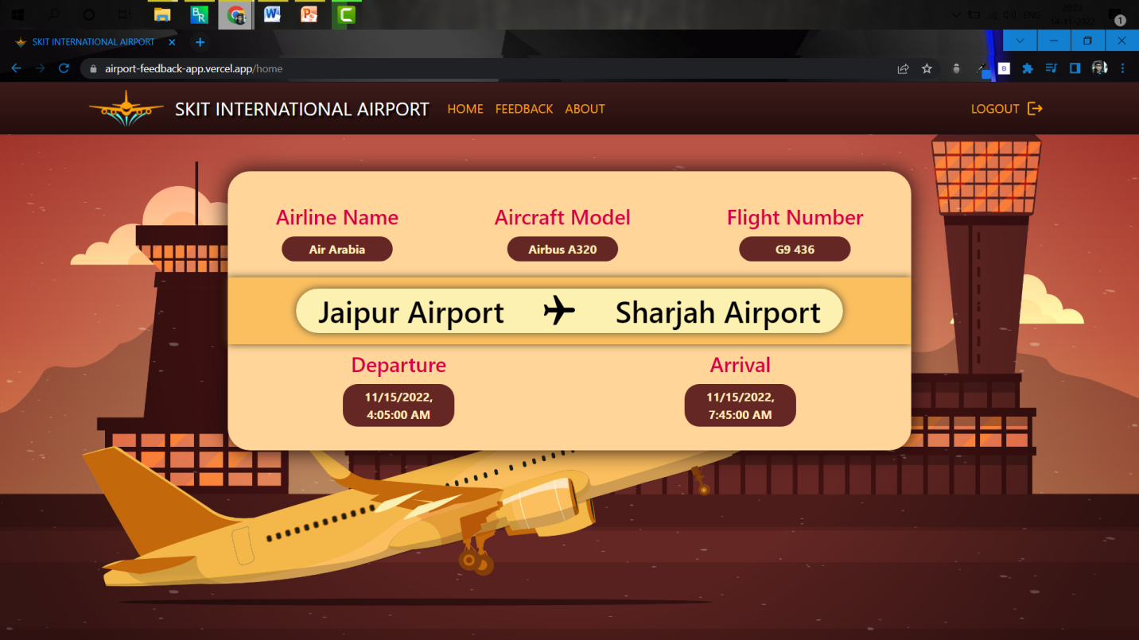

**Fig 7.2: Passenger Home Displaying Flight Details**

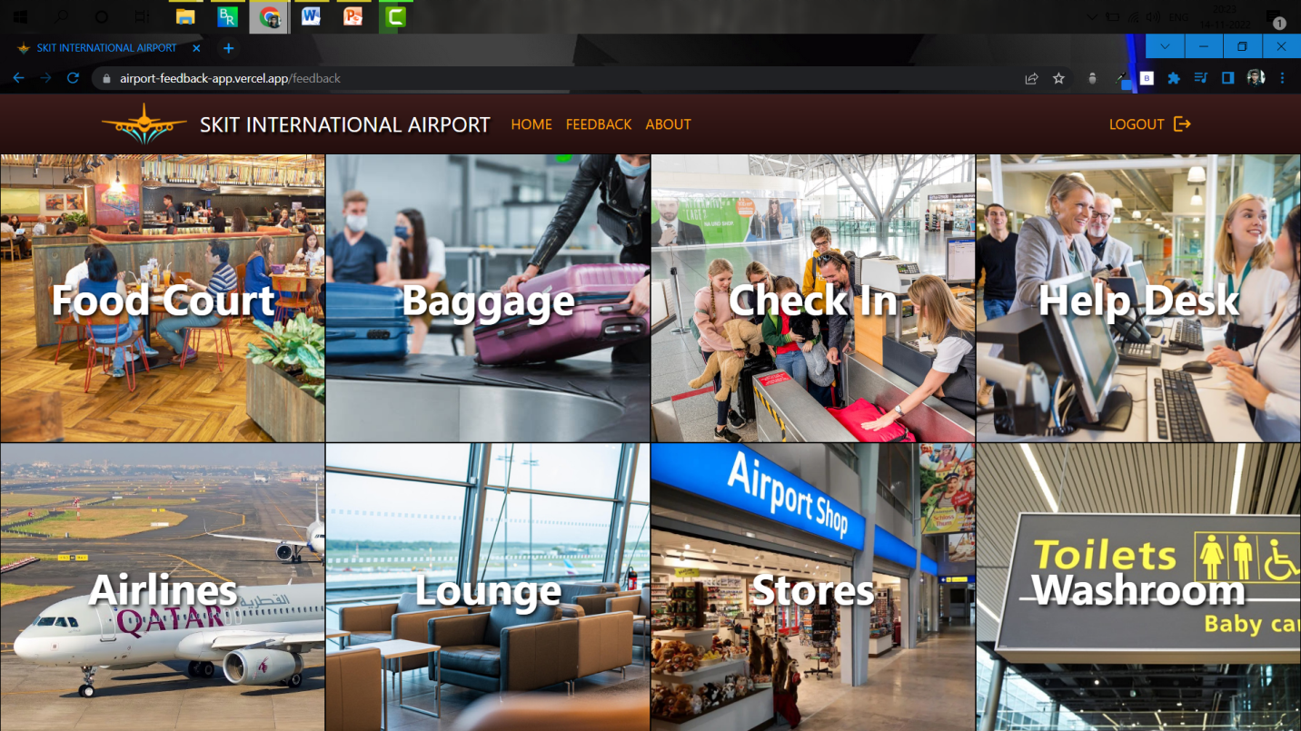

**Fig 7.3: Feedback Page (Common for both Passenger & Admin)**

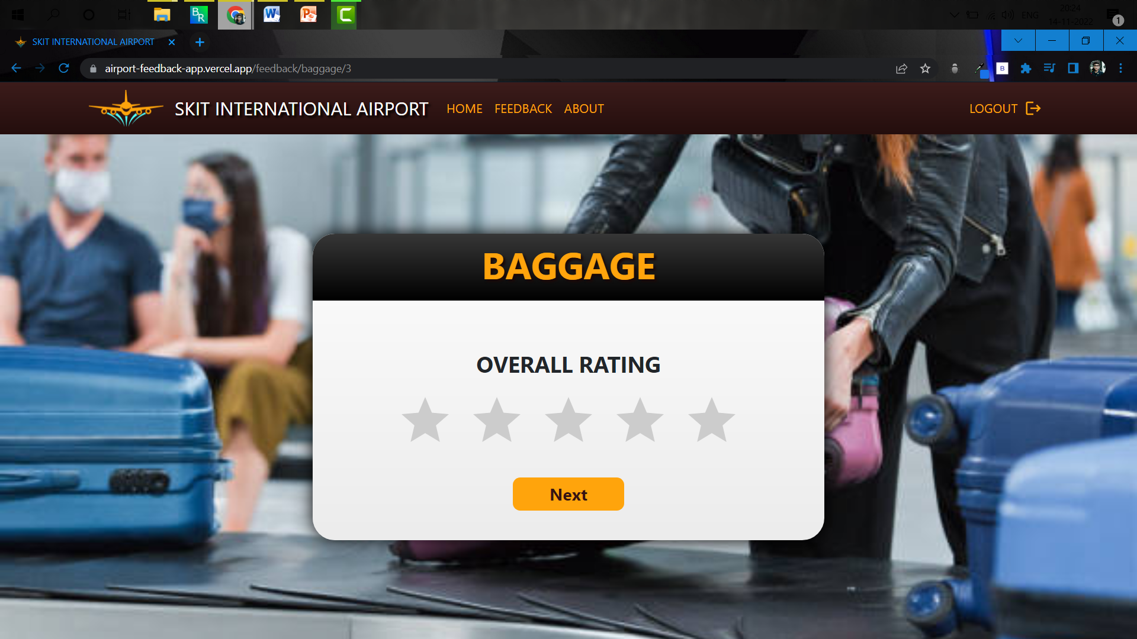

**Fig 7.4: Passenger Rating Form**

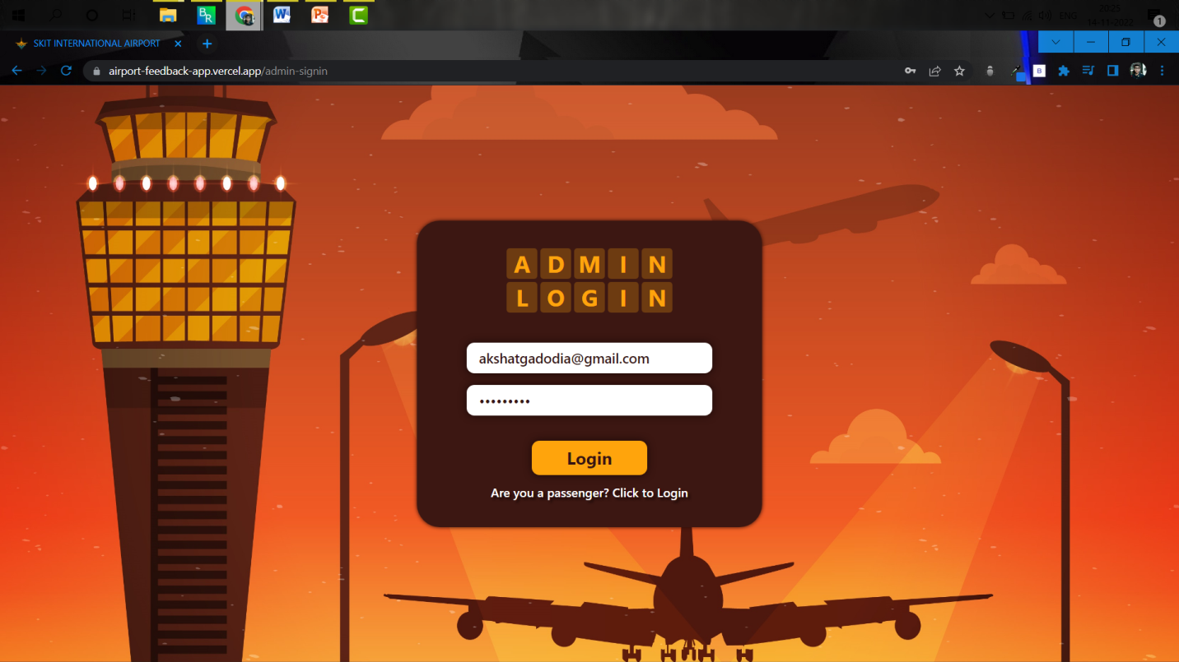

**Fig 7.5: Admin Login Page**

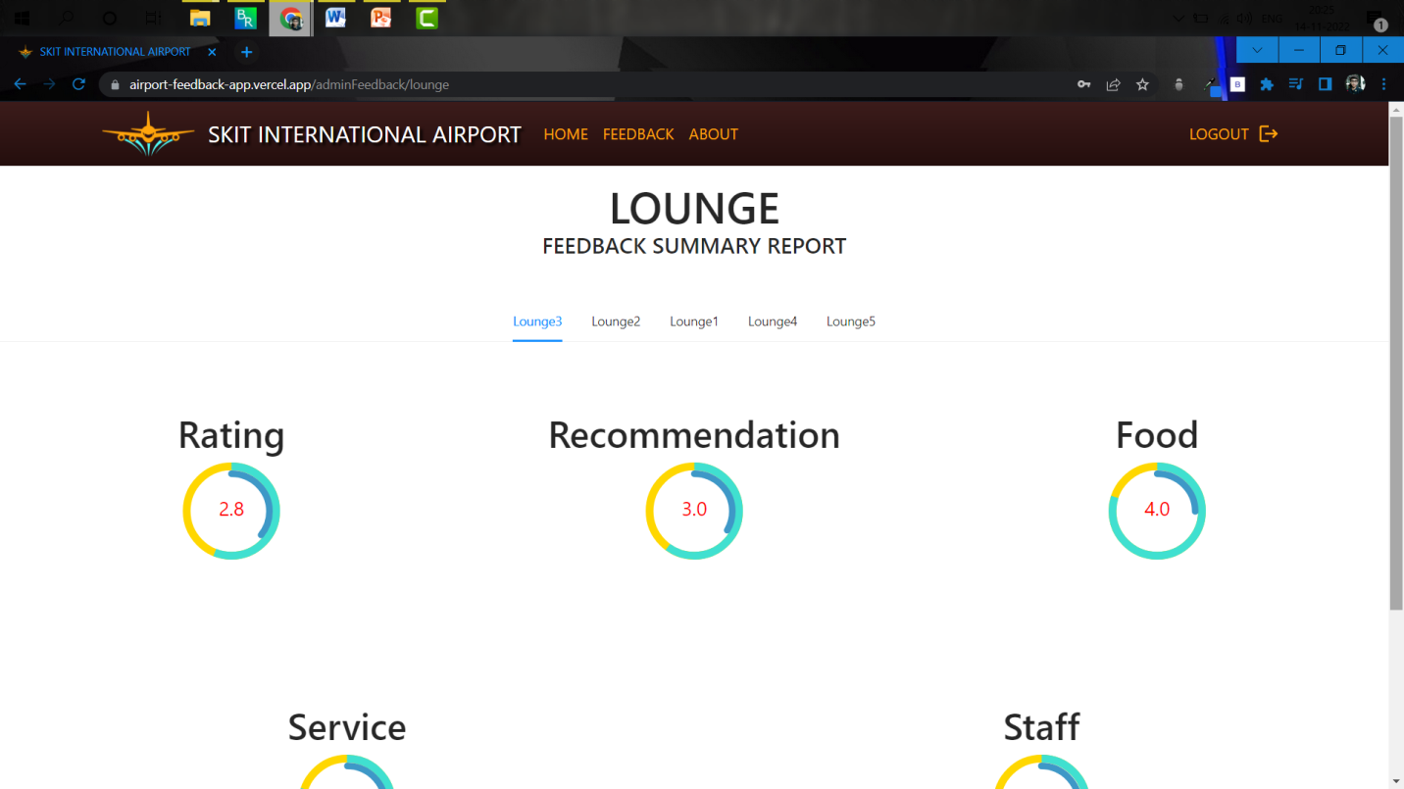

**Fig 7.6: Lounge View Feedback Page**

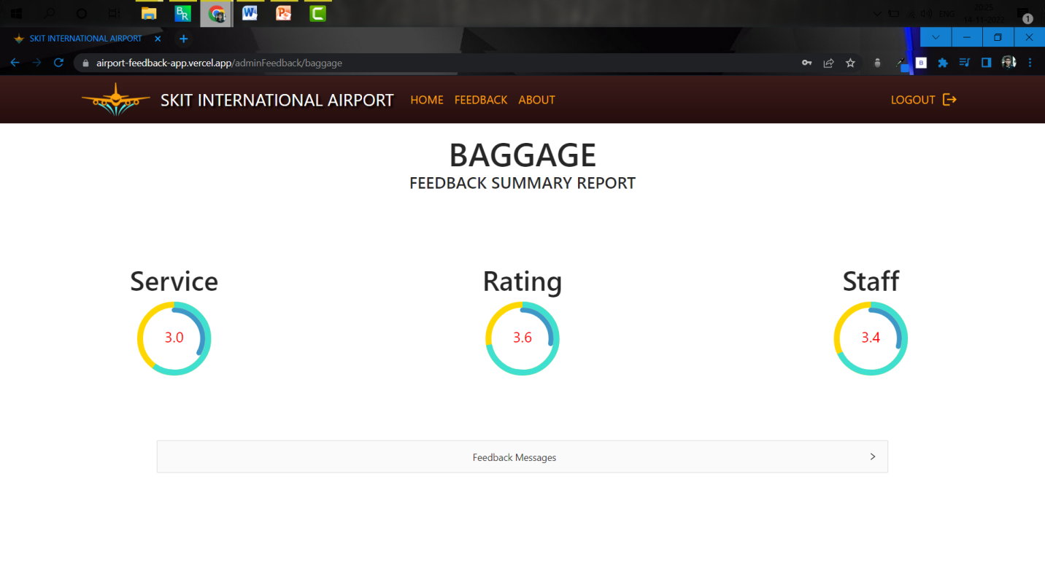

**Fig 7.7: Baggage View Feedback Page**

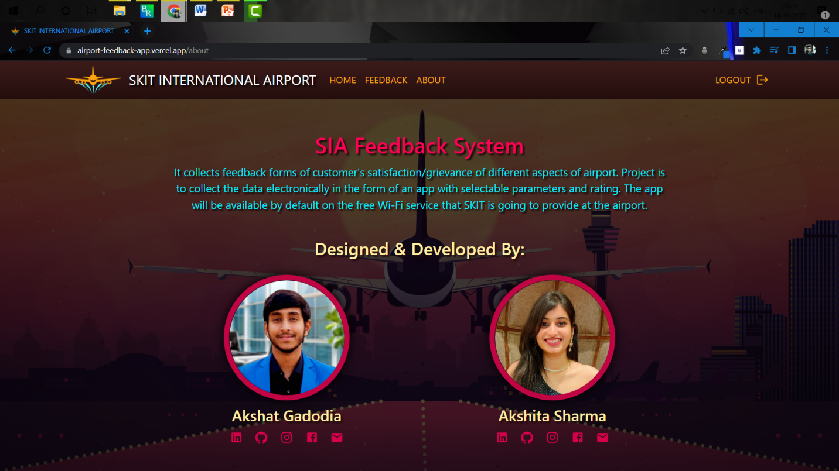

**Fig 7.8: About Page**

**Chapter 8**

**Project Summary and Conclusions**

**8.1 Conclusion**

"In the IT industry you are in the business of your employee’s Skills and Knowledge. This is the most important selling factor for grabbing a new business as well as for sustaining and growing the existing businesses," competition is further forcing organizations to be 100 percent aware of their employee’s skills and abilities. With companies becoming aware of their employee’s skills, more than ever before the skills tracking exercise have achieved serious proportions, almost at par with other regular internal employee programmers.

While some progressive organizations had started the skills tracking exercise some time back, others are now following suit. "These initiatives are becoming more integral to forward looking it companies, who have the tremendous need to tap into the employee talent reservoir to provide value add to their business operations and customers and, in turn, help employees to explore their potentialities.

Most progressive organizations have skill evaluation as a formal program. An employee's customized development plans are made reflecting his/hers skills and talents. These exercises are conducted in addition to the informal programs. Most large it companies maintain a central skills inventory of their employees. Companies are currently conducting these programs from time to time as and when required, but the IT industry is looking at this with complete focus.

Many companies are even introducing web-based tracking system, which is more prevalent in the west." employee-skill inventory is becoming a major source for designing training and development programs, as well as becoming an integral part of HRM systems—whether automated or otherwise— in it companies. For organizations where formal programs are still a distant reality on account of resource constraints, conduction of informal exercises at least is becoming an acceptable norm.

**Chapter 9**

**Future Scope**

The possible future scope of this application will be on mobile platform with following enhancements:

* SAAF will be enhanced up to all departments of SAAF group.
* Integrating leave management and attendance system.
* Apply machine learning to generate meaningful trends and results.
* Integrating complaint system.

**References**

* Object Oriented Modeling and Design with UML-Michael Blaha, James Rambaugh.
* Software Engineering, Seventh Edition, Ian Sommerville.
* Wikipedia - [*www.wikipedia.com*](http://www.wikipedia.com)
* MongoDB *-* [*www.mongodb.com*](https://www.mongodb.com/docs/manual/tutorial/getting-started/)
* Node.js*-* [*www.w3schools.com*](https://www.w3schools.com/nodejs/)
* Express.js *-*[*www.tutorialspoint.com*](https://www.tutorialspoint.com/expressjs/index.htm)
* React.js *-* [*www.reactjs.org*](https://reactjs.org/tutorial/tutorial.html)

**Project Links**

* **GitHub Repository**

[**https://github.com/akshatgadodia/airport-feedback-app**](https://github.com/akshatgadodia/airport-feedback-app)

* **Deployed Application**

[**https://airport-feedback-app.vercel.app/**](https://airport-feedback-app.vercel.app/)